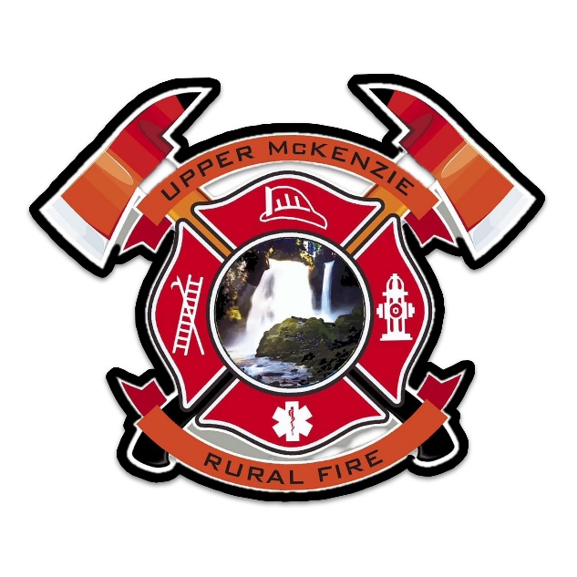

**UPPER MCKENZIE RURAL**

**FIRE PROTECTION DISTRICT**

Budget Committee Meeting

**May 19th, 2025**

Meeting at 7 pm (prior to Board Meeting)

**Located at the Blue River Fire Station**